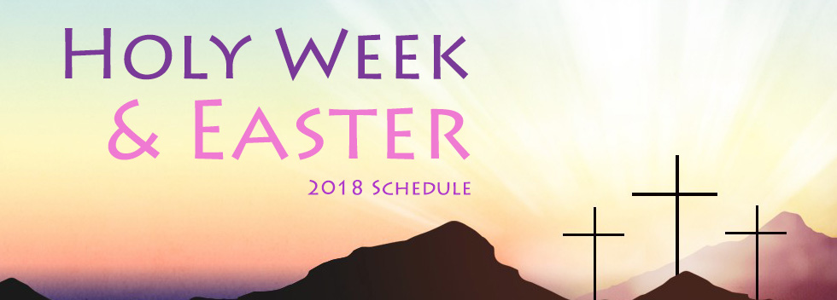
EASTER MASS SCHEDULE 2018
I invite you to join our community over the Easter period. The liturgical schedule is below.
Reconciliation: Wednesday March 28 at 7.30 to 8pm. Saturday 31 March 4-5pm.
Palm Sunday: Celebration of the Lord’s triumphal entry into the city of David, Jerusalem.
Mass times: Saturday Vigl: 5.30pm Sunday: 7.30 and 9am
Holy Thursday We celebrate the Lord’s Supper, the institution of the Eucharist (First mass) and the Ministerial Priesthood.
Mass Times: The Lord’s Supper: 7.30pm
Good Friday: We walk with Jesus Christ through His Passion and Death.
“Greater love no man has than to lay down His life for His friends.”
Stations of the Cross: 9am
This is an opportunity for us to reflect on the passion and suffering of Jesus for us and our sins.
Liturgical Action of the Lord’s Passion: 3pm
Good Friday afternoon we enter into the passion and death of Jesus who died for me.
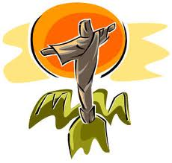
There are 4 parts to the Liturgy
1. The Word of God-Scripture Readings
2. The reading of the passion from St John’s Gospel
3. The Prayers and veneration of the Cross
4. Holy Communion
The Liturgy begins at 3pm.
Holy Saturday: 5.30pm The Church waits for its Lord to rise from death to life and a life that we now share. The Easter Vigil is the Solemn Celebration of the Lord’s rising from the dead.
The parts of the Vigil are:
1. The lighting of the Easter Fire and lighting of the Easter Candle
2. Readings telling salvation history
3. Renewal of Baptism vows
4. Celebration of the Easter Sacrament

The Easter Sunday Masses Are: 7.30am and 9am

Wishing all parishioners and visitors to St Anthony’s a Blessed Easter

Fr Bob Hayes PP RFD VF 